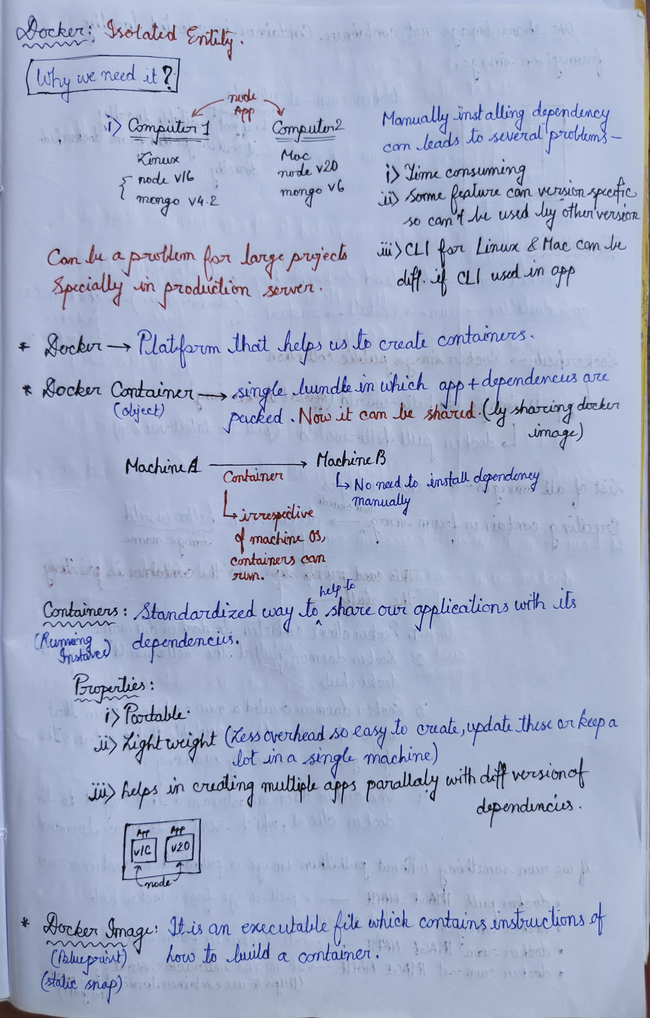

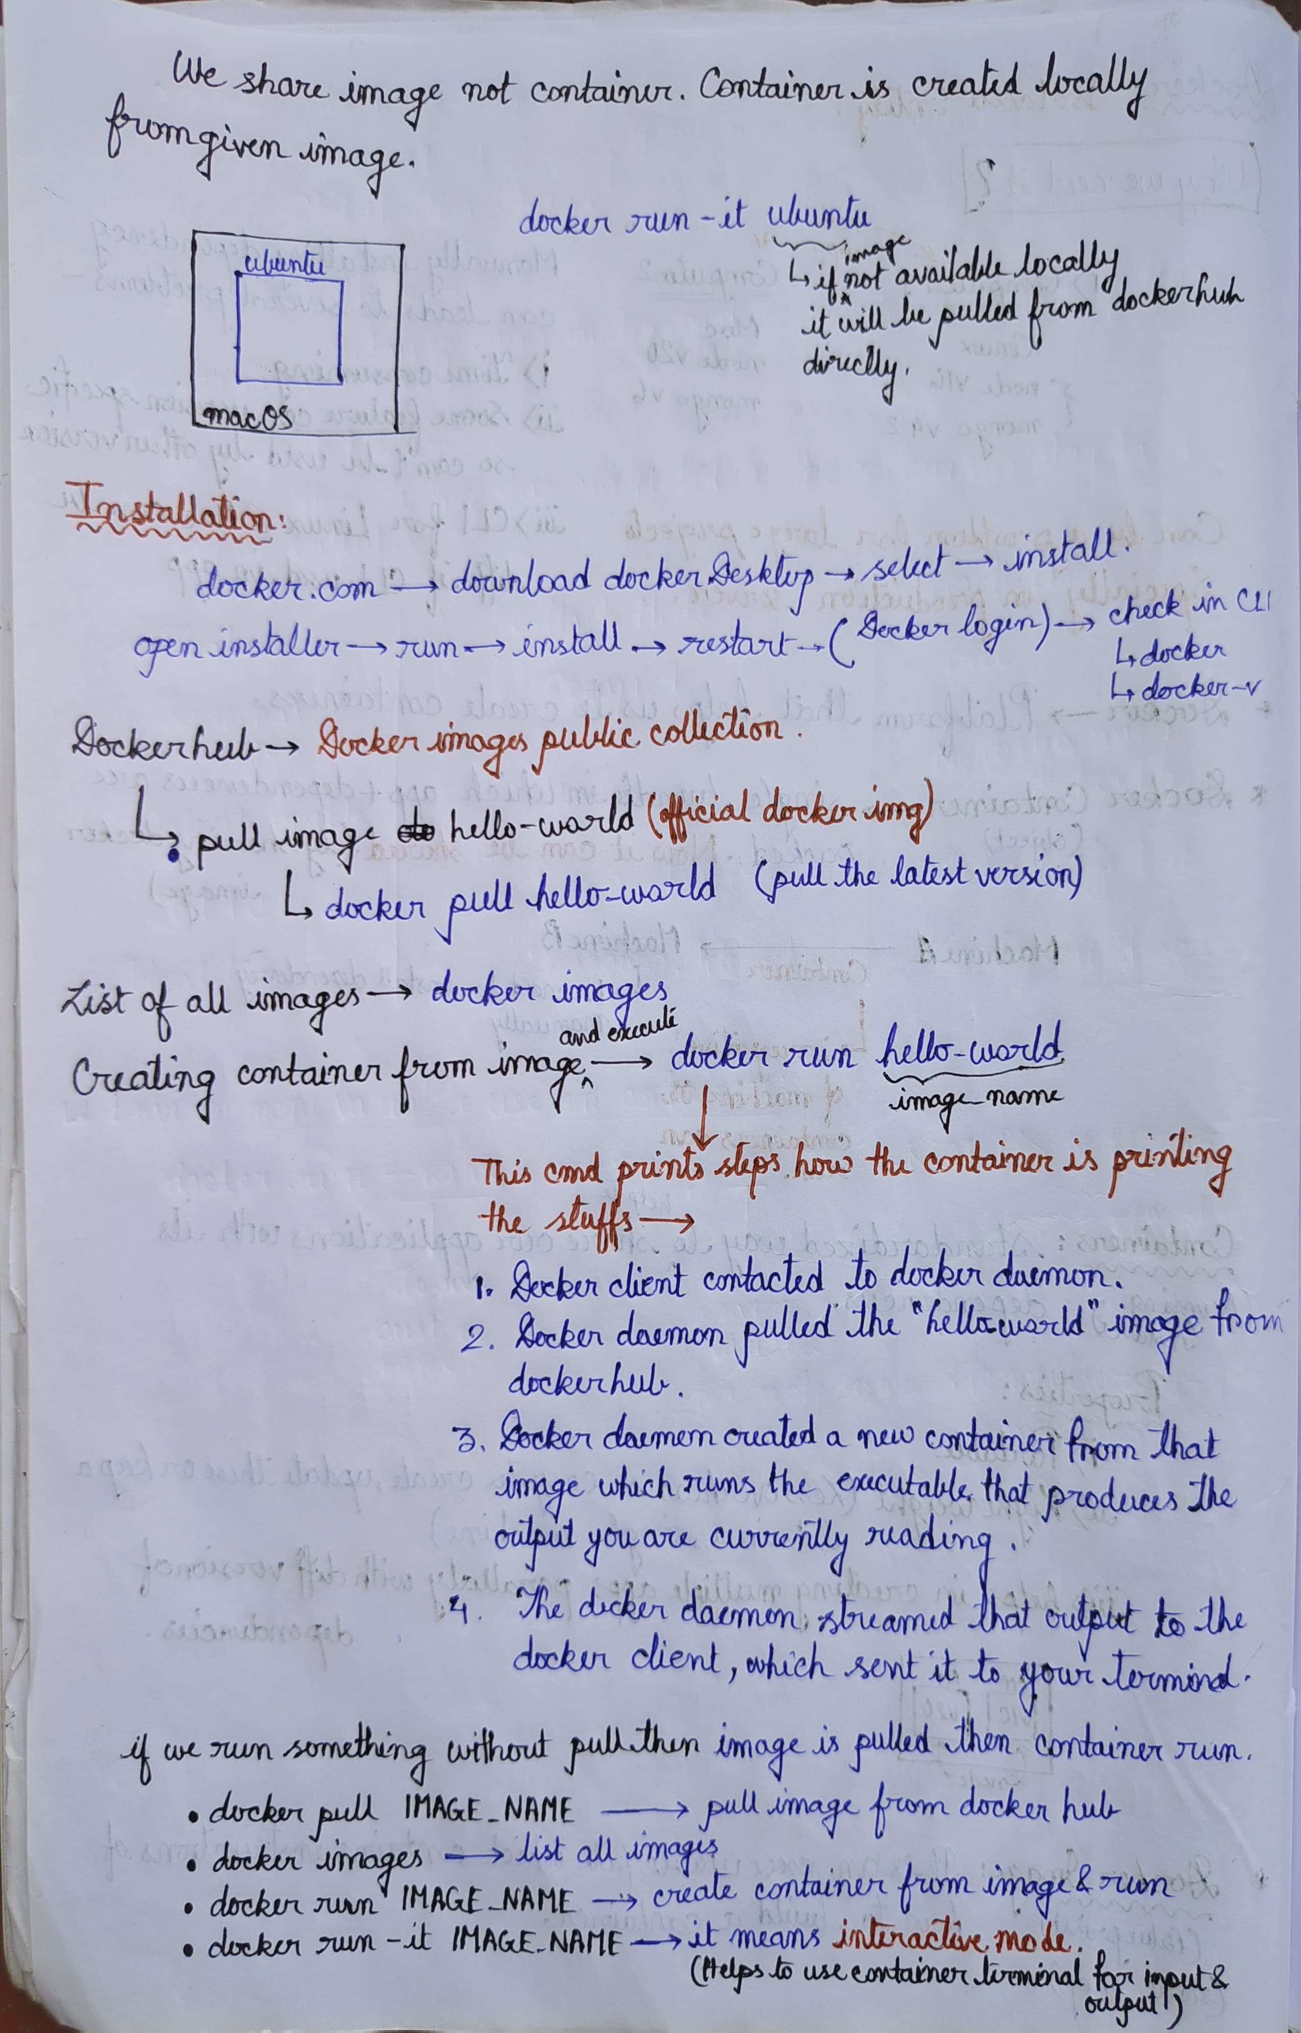

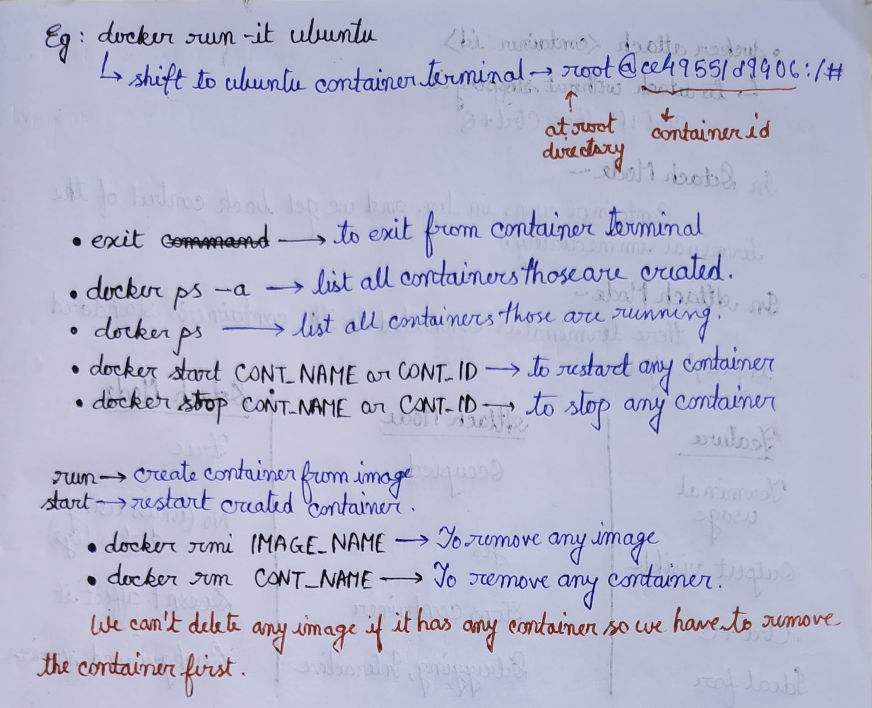

**Docker Version-**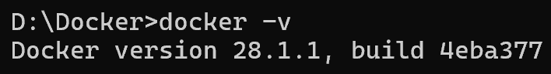

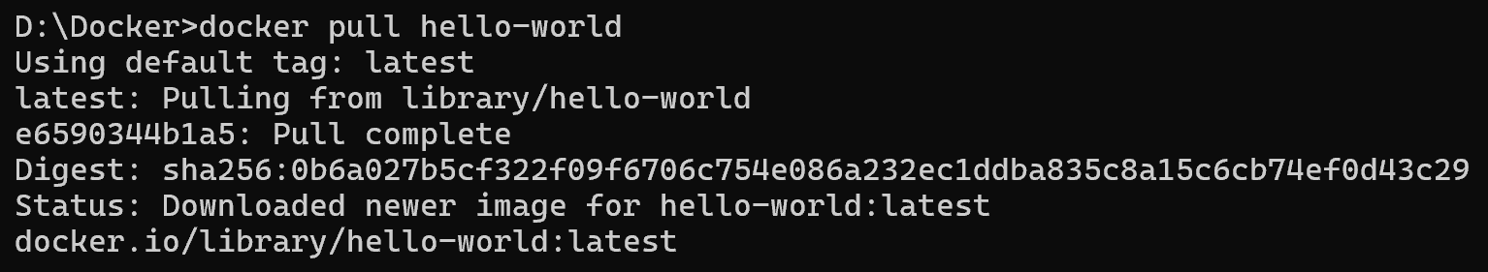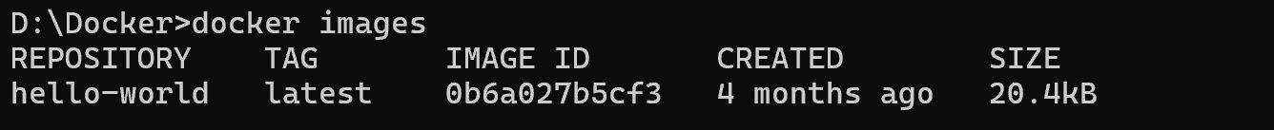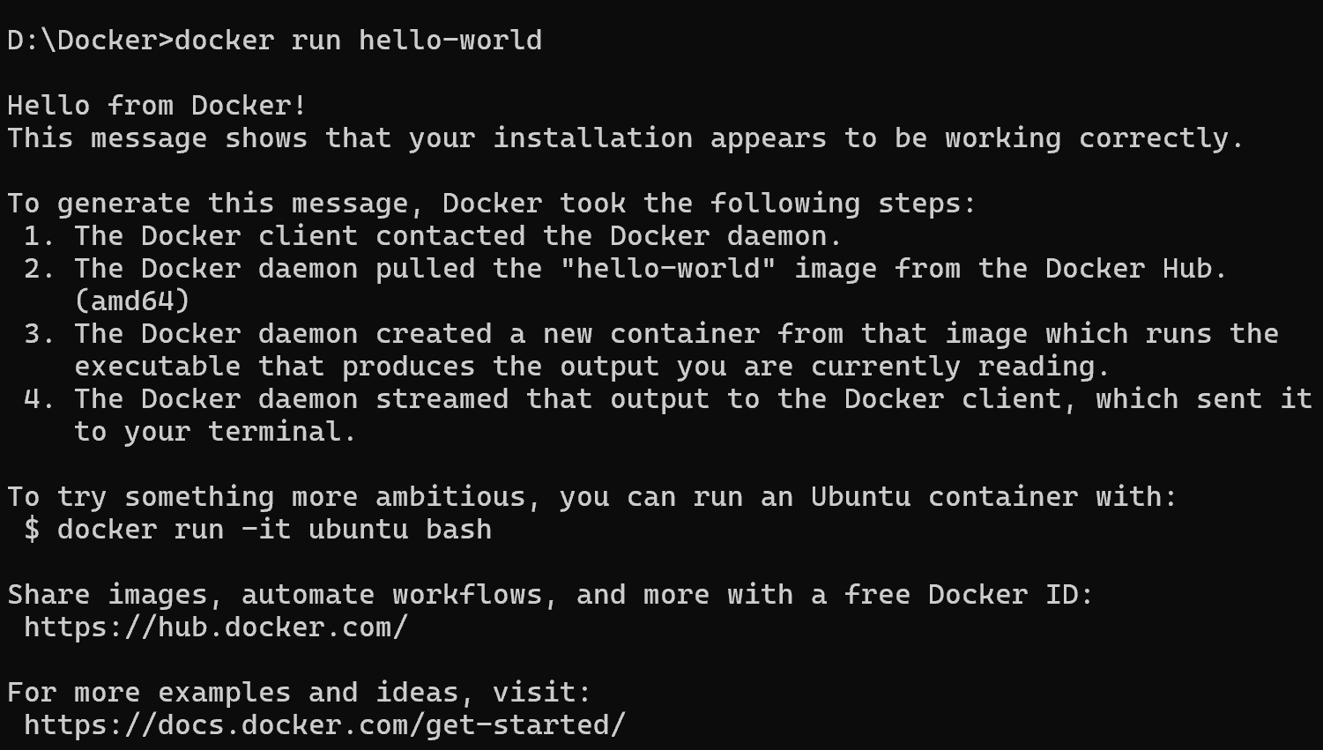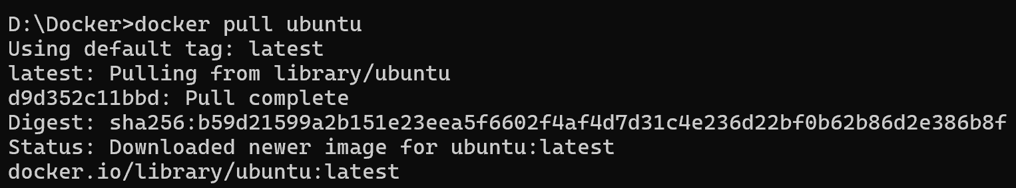

**Shift to ubuntu container terminal** 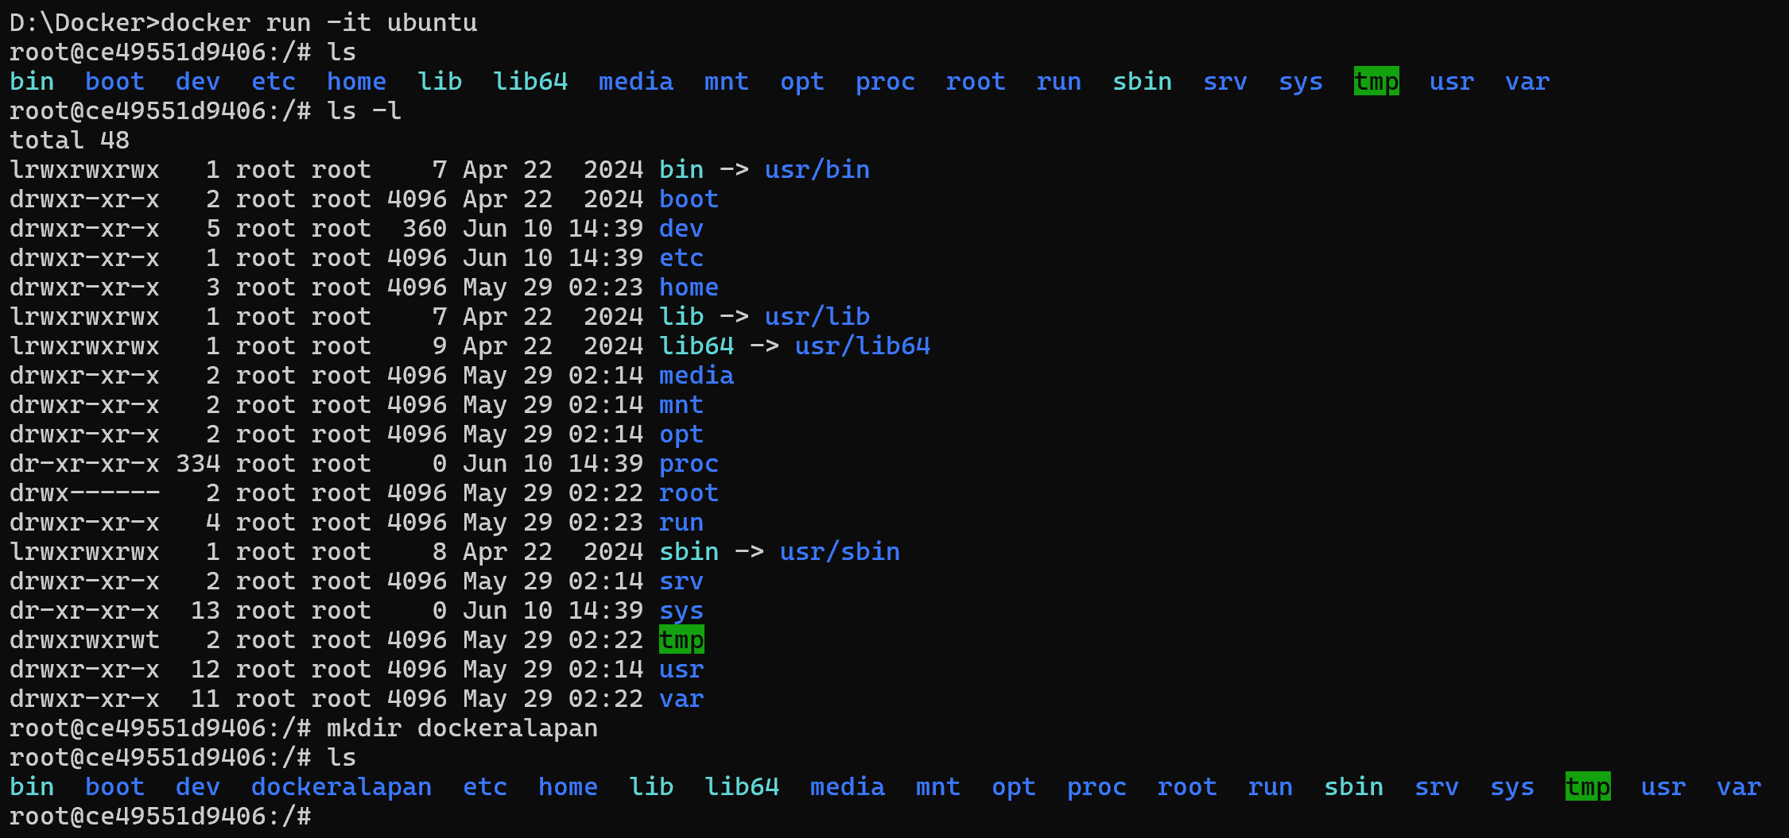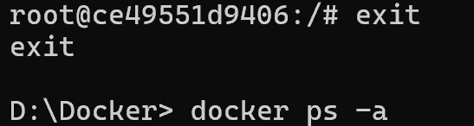

**docker ps -a: List all containers those are created**

**docker ps : List all running containers**

**docker start<id or name>: restart any created container**

**Start with id**

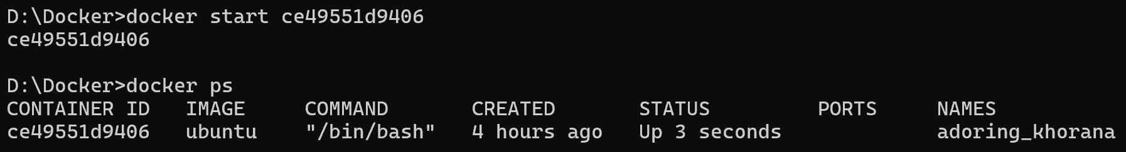

**Start with container name**

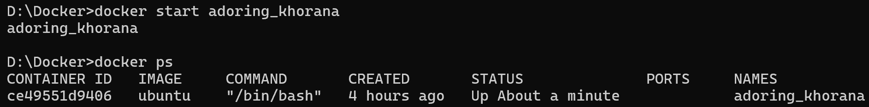

**Docker stop <id or name>: To stop any container**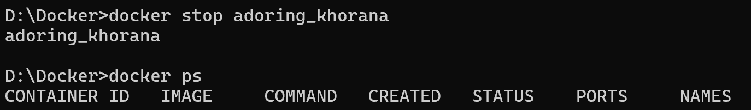

**rmi : To remove any image**

**Error because this image already has a container. To delete image we have to delete the container first.**

**rm : to remove any container**

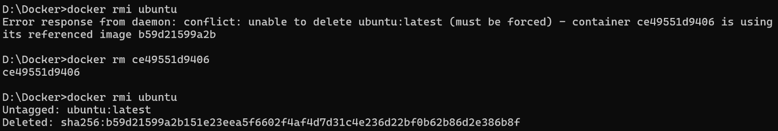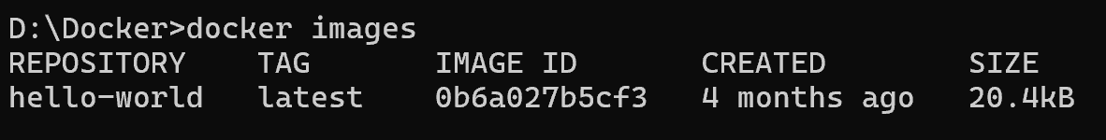

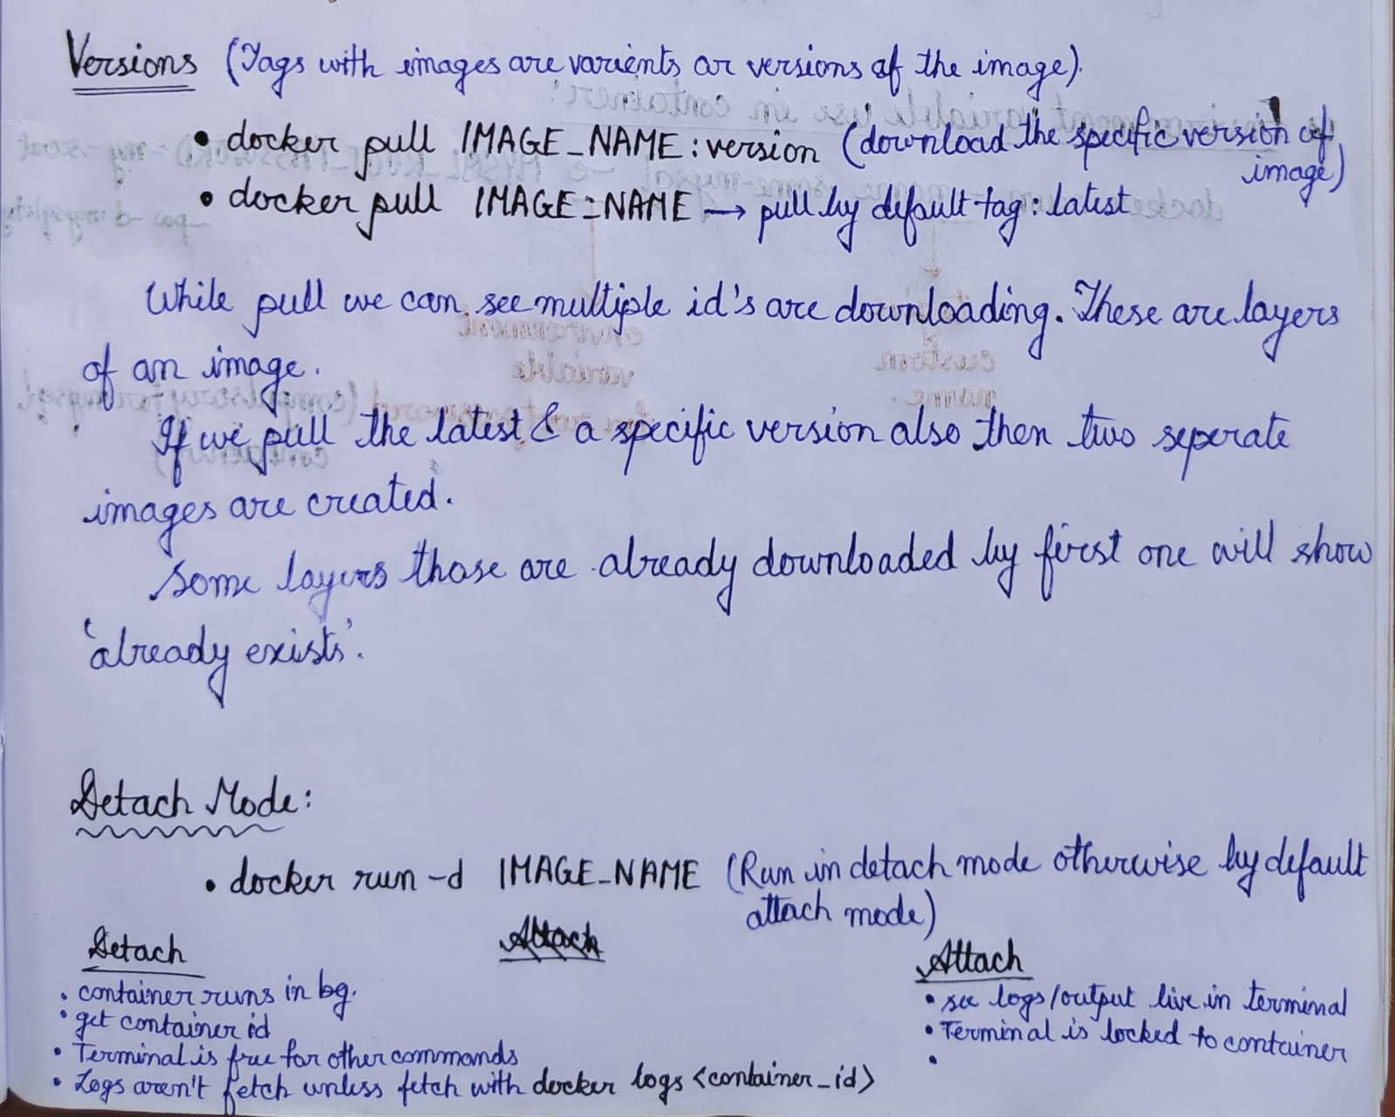

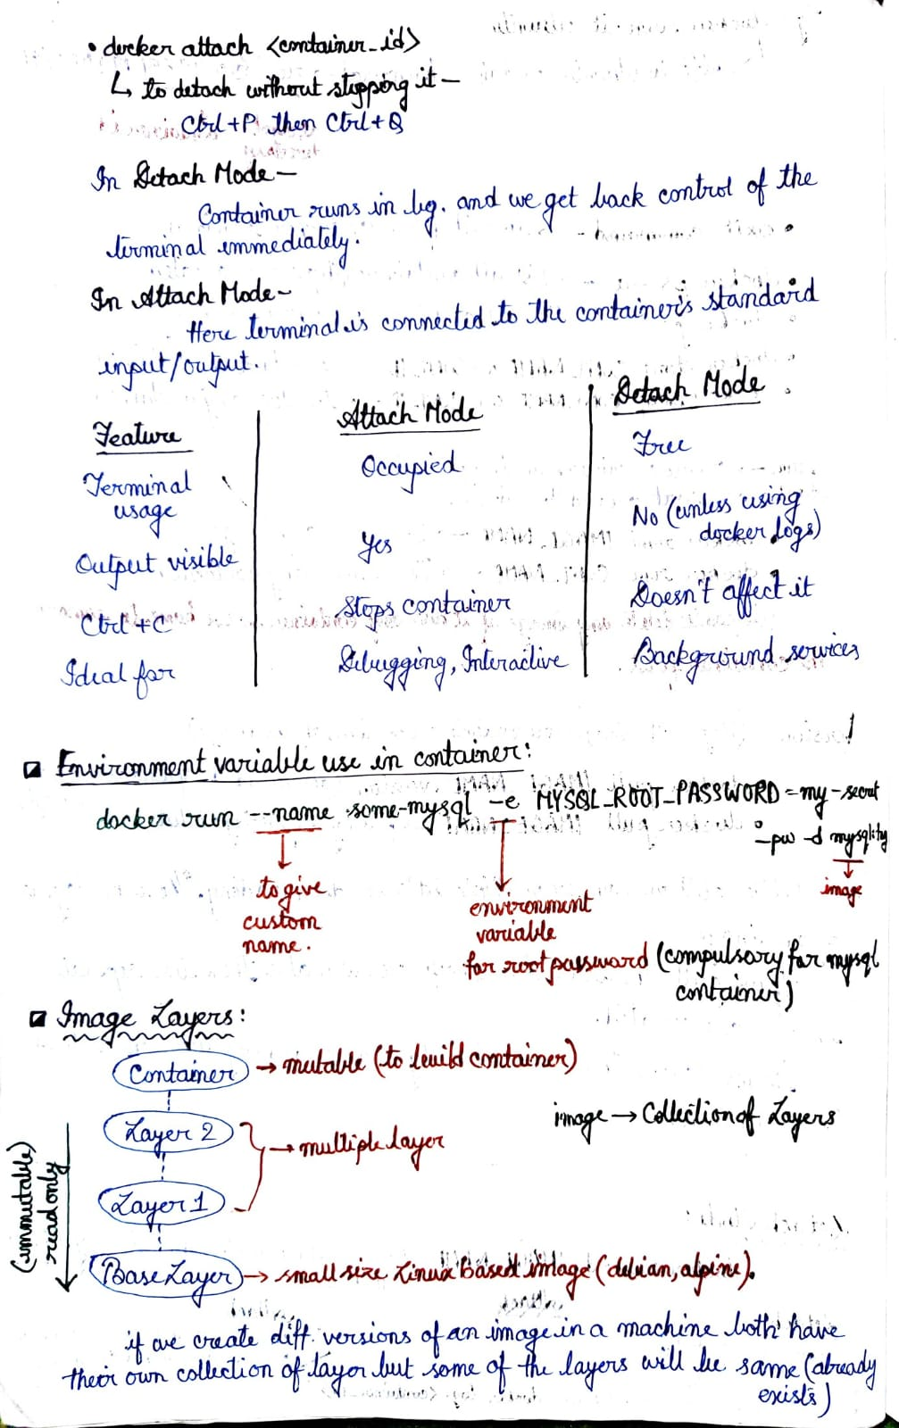

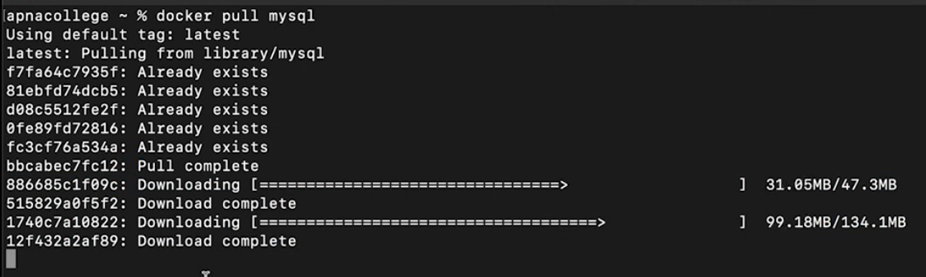

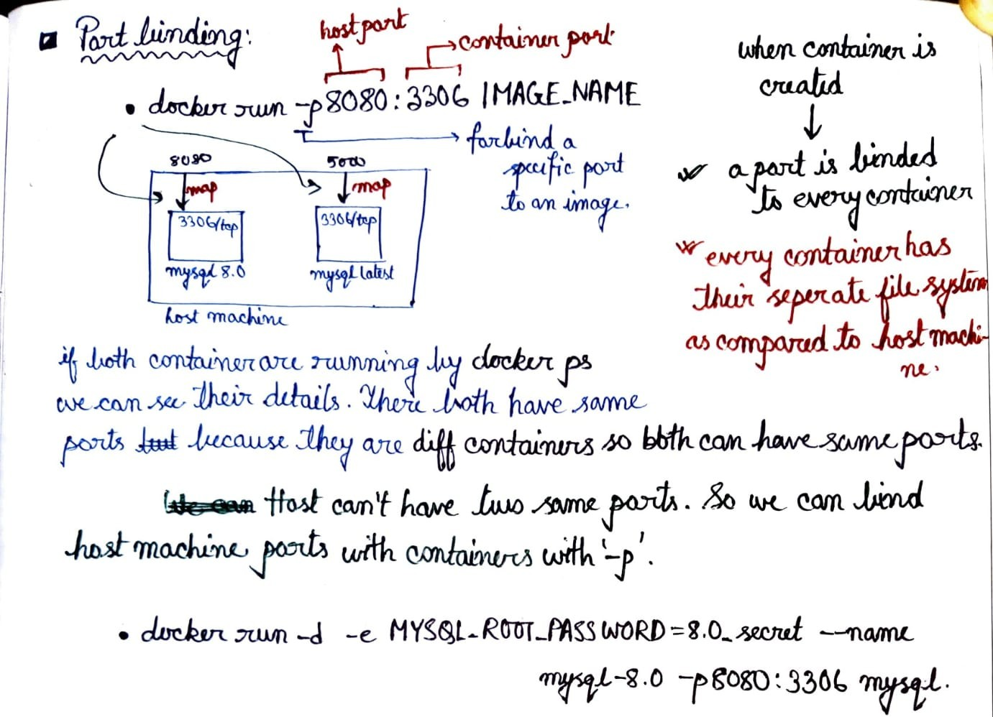

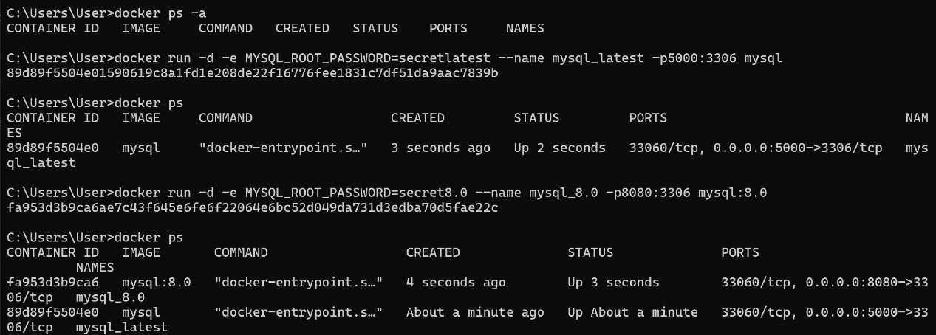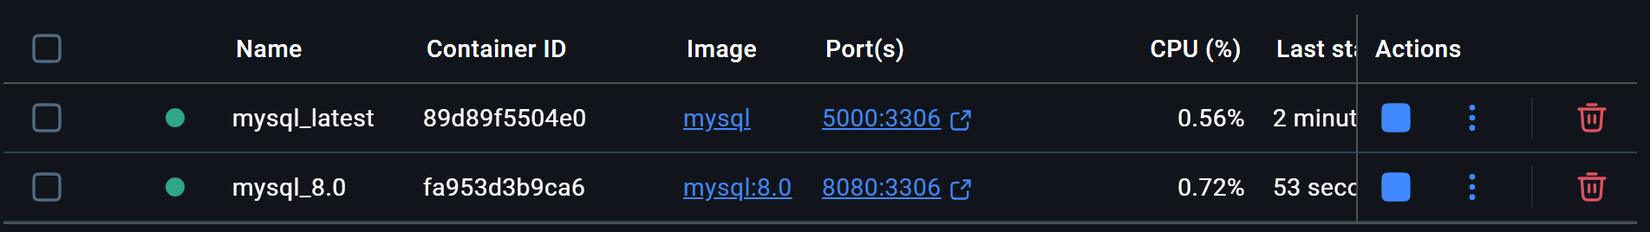

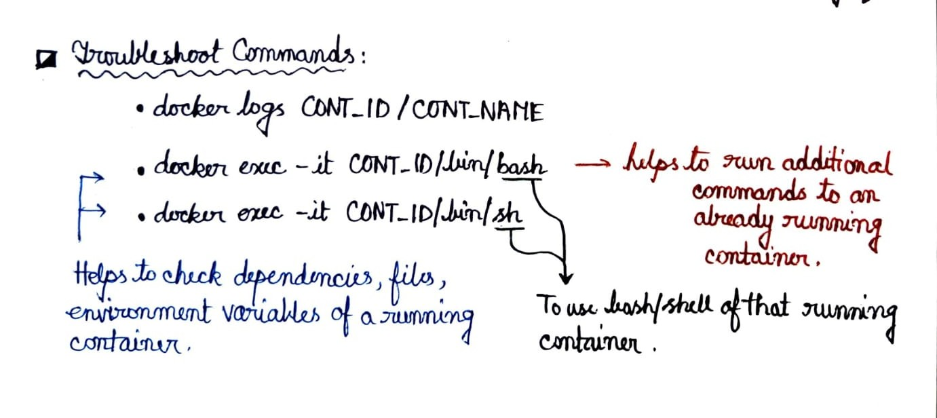

**Logs can be checked from docker desktop by clicking the container name**

